**Random Forest :Cases**

Mostly cases for DT are also apply for RF like if there is large dimensions and categorical features with many categories then it is not good to use DT similarly in this case we don’t use RF as well.

1. Bias variance :

In DT for bias variance tradeoff we use depth to control it.

But in RF we use k(no. of base learners) to control it.

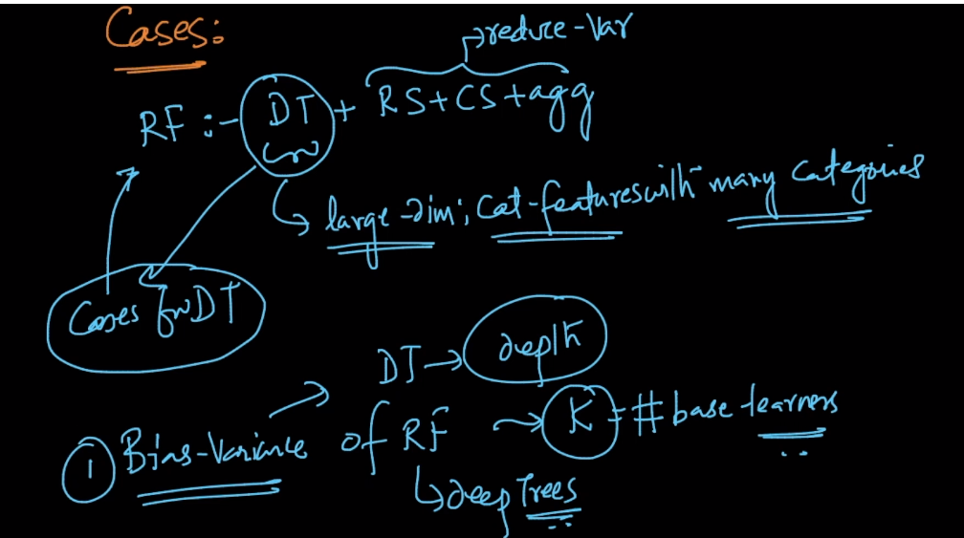

1. Feature Importance :

In DT we find feature importance of feature fi by calculating overall reduction in entropy or gini impurity Ig because of this feature fi at various levels in the DT.

But as in RF there are K DT’s therefore feature importance of feature fi is find by calculating overall reduction in entropy or gini impurity Ig because of this feature fi at various levels in the DT of each models Mi’s

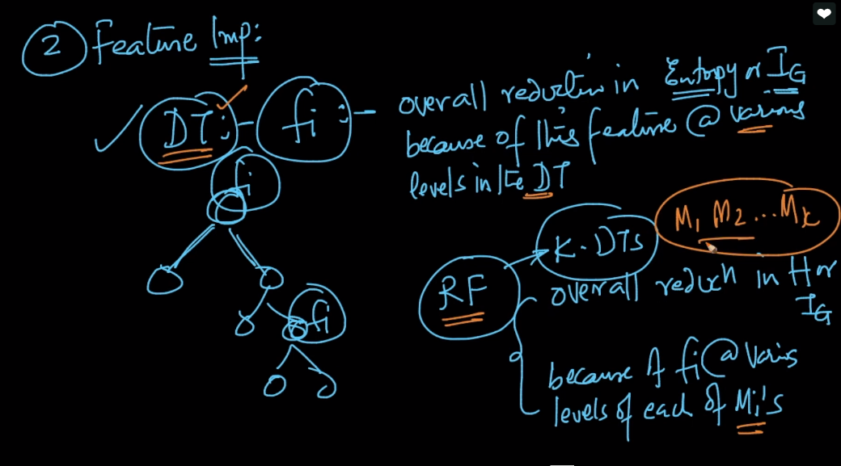

Comments :

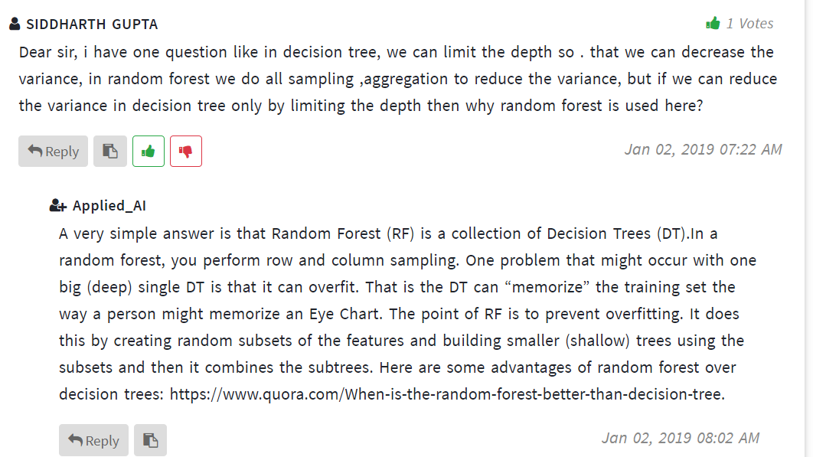

Random forest links :

https://www.youtube.com/watch?v=J4Wdy0Wc_xQ